This confidential information is provided to you in accord with State and Federal laws or regulations including applicable Welfare Institutions Code, Civil Code, and HIPAA Privacy Standards. Duplication of this information for further disclosure is prohibited without prior written authorization of the client/authorized representative to whom it pertains unless otherwise permitted by law.

Treatment Plan
Client Legal Name: Daniel Lezama
Member ID: 3532083
Client Date of Birth: 2/2/2020
Client Age: 6 years old
Guardian Name and Contact Information: Claudette (claudettelara@gmail.com) and Arnoldo Lezama (adlezama1909@gmail.com), 443-956-1441
BCBA: Shelly Engel, M.S., BCBA LBA
Reporting Period: September 2025 – February 2026
Requested Authorization Period: March 2026 – September 2026
Date of Report: 2/16/2026

Background Information:
Family Background: Daniel lives at home with his mother, father, and baby sister Violette in an apartment in Aberdeen, MD. Mrs. Lezama works from home and Mr. Lezama words 4 days a week outside of the home.
Cultural Considerations: There are no cultural and/or spiritual considerations at this time. The English and Spanish language are both spoken in the home.
Client/Caregiver Treatment Priorities: Mr. and Mrs. Lezama report that she would like to see Daniel accomplish the following with ABA services;
- Increase his communication
- Decrease maladaptive behaviors
- Socialize and integrate with peers

Developmental & Medical Background

Diagnosis: Daniel was diagnosed with Autism Spectrum Disorder with an accompanying language impairment by Tiffany A. Garner, Psy. D. on 5/24/2024. Current severity is identified as Level 2 for Social Communication and Level 1 for Restricted and Repetitive Behaviors.
Medications: Over the counter multivitamin 1 time per day, Dyanavel XR 2.5 mL every morning for ADHD symptoms
Allergies: He has an allergy to rambutan, a fruit native to Honduras
Current Level of Supports: Daniel communicates using 2-3 word phrases. Daniel is toilet trained and is able to request the bathroom as needed. Daniel requires adult support to consume his entire meal , as without adult support he is likely to engage in other activities. Daniel engages in cooperative play with peers and will mand to peers with prompts from staff. Daniel can tact noun-verbs, identify multiple exemplars of an item, and identify items based on 3 clues.

Intervention History & Current Services

Referral Information: Daniel was referred to ABA services by Tiffany A. Garner, Psy. D. on 5/24/2024.
ABA Services: Daniel began receiving ABA services 9/3/2024. He currently receives services Monday-Friday from 8:00am-4:00pm in the clinic setting for a total of 40 hours per week.
Other Services: N/A
Changes to Services: were no gaps in services during this time. Daniel began working with a new AM technician on 9/9/25, and a new PM technician on 9/28/25.
Coordination of Care: Daniel does not receive any other services outside of ABA.

Risk Assessment:
The potential risks of treatment have been outlined in the Client Services Agreement provided to and signed by the family at the start of treatment and annually thereafter. Any further risks will be addressed by the BCBA using the least restrictive measures possible. Goals that reduce future risk will be prioritized for treatment. Caregiver non-adherence with treatment recommendations may result in decreased benefits from treatment.

There are limited risks for Daniel to engage in ABA services at this time. His communication and social skill deficits are impacting his ability to effectively indicate his wants and needs as well as to socialize appropriately with others. There are safety concerns regarding his target behavior for decrease, such as elopement, aggression, and tantrum, property destruction, dropping, and mouthing. The maladaptive behaviors are interfering with Daniel’s ability to learn new skills, as well as having meaningful social interactions. Throughout treatment, least restrictive measures will be utilized prior to more restrictive procedure. Proactive measures to teach more socially appropriate, and functionally equivalent behavior to replace behaviors targeted for decrease will be added to Daniel’s treatment plan.

Preference Assessment:

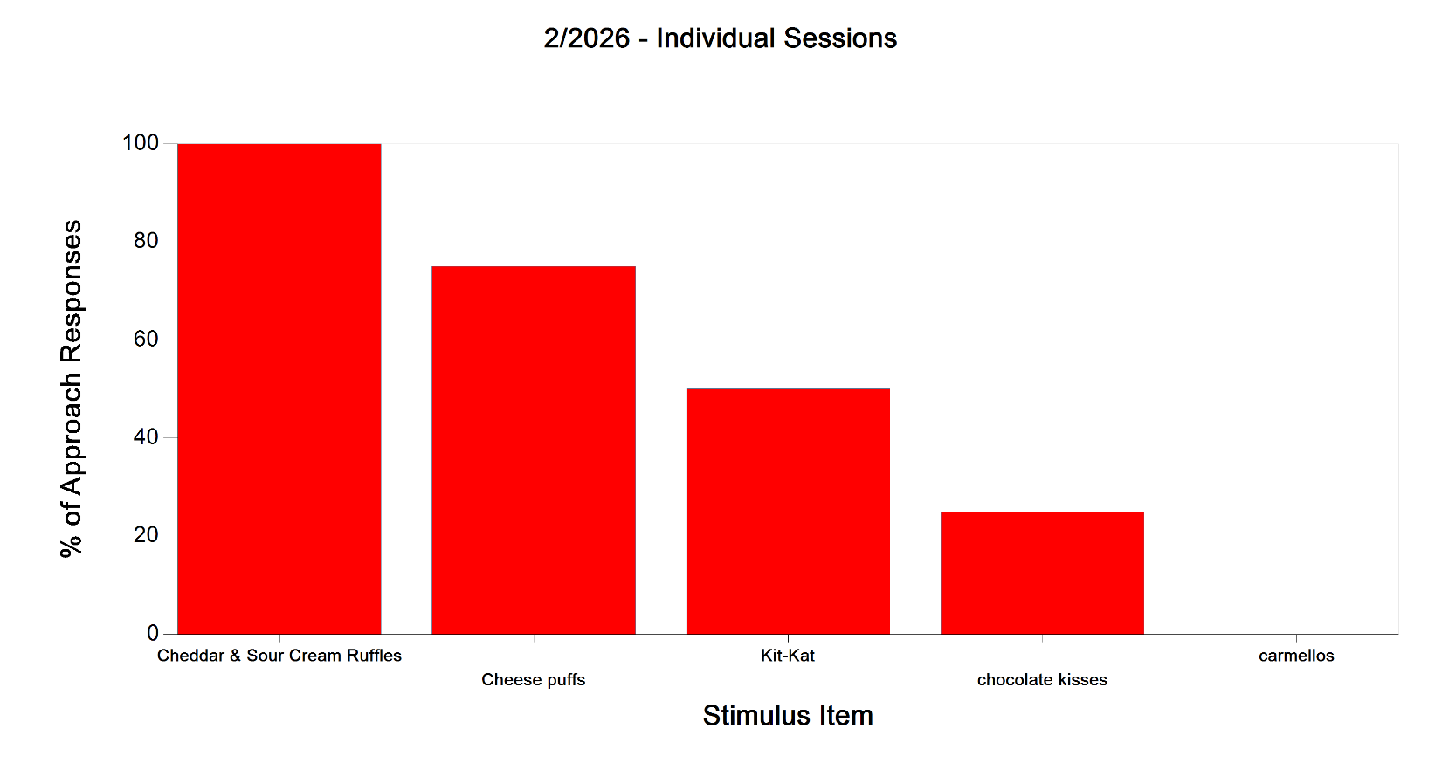

Figure 1: Paired choice preference assessment results for Daniel Lezama.

Assessment Tools/Measures:

Vineland-3
The Vineland Adaptive Behavior Scales, Third Edition (Vineland-3) is an individually administered measure of adaptive behavior for individuals with intellectual, developmental, and other disabilities. The Vineland-3 is a standardized measure that assesses the things that people do to function in their everyday lives. Whereas ability measures focus on what the examinee can do in a testing situation, the Vineland-3 focuses on what he or she does in daily life. Because it is a norm-based instrument, the examinee's adaptive functioning is compared to that of others his age. There are 3 administration forms: The Interview Form, the Parent/Caregiver Form, and the Teacher Form. Trellis utilized the Parent/Caregiver form during this reporting period. The Parent/Caregiver Form provides normative scores across the lifespan, from birth through age 90+. The Vineland-3 covers 3 main domains: communication, daily living skills, and socialization, and includes optional motor skills and maladaptive behavior domains. An individual’s overall level of adaptive functioning is described by the score on the Adaptive Behavior Composite (ABC). The ABC score is based on scores for three specific adaptive behavior domains: Communication, Daily Living Skills, and Socialization. The domain scores are also expressed as standard scores with a mean of 100 and a standard deviation of 15.

 | Baseline Administration Date: 8/13/24 |  |  |  | Current Administration Date: 8/2/25
Domain | Standard  Score | v-Scale Score | Age  Equivalent | Adaptive Level | Standard  Score | v-Scale Score | Age  Equivalent | Adaptive Level
Communication | 65 |  |  | Low | 76 |  |  | Moderately Low
Receptive |  | 9 | 1:10 | Low |  | 11 | 2:8 | Moderately Low
Expressive |  | 6 | 1:6 | Low |  | 9 | 2:0 | Low
Written |  | 10 | <3:0 | Moderately Low |  | 12 | 4:4 | Moderately Low
Daily Living Skills | 81 |  |  | Moderately Low | 95 |  |  | Moderately Low
Personal |  | 12 | 3:1 | Moderately Low |  | 14 | 4:10 | Adequate
Domestic |  | 10 | <3:0 | Moderately Low |  | 16 | 7:0 | Adequate
Community |  | 13 | 3:0 | Adequate |  | 22 | 3:2 | High
Socialization | 79 |  |  | Moderately Low | 85 |  |  | Moderately Low
Interpersonal |  | 10 | 1:6 | Moderately Low |  | 12 | 3:0 | Moderately Low
Play/Leisure |  | 12 | 2:3 | Moderately Low |  | 11 | 2:2 | Moderately Low
Coping Skills |  | 11 | <2:0 | Moderately Low |  | 14 | 3:8 | Adequate
Motor Skills | 89 |  |  | Adequate | 83 |  |  | Moderately Low
Gross Motor |  | 17 | 2:8 | Moderately Low |  | 15 | 5:6 | Adequate
Fine Motor |  | 10 | 6:3 | Adequate |  | 10 | 3:2 | Moderately Low
Adaptive Behavior Composite | 74 |  |  | Moderately Low | 82 |  |  | Moderately Low
Maladaptive Behavior
Internalizing |  | 15 |  | Adequate |  | 19 |  | Moderately High
Externalizing |  | 18 |  | Moderately Low |  | 21 |  | High

Figure 2. Vineland Results for Daniel Lezama.

Baseline information should never change. The standard scores reported have an average of 100 and a standard deviation of 15. Age‐equivalents indicate the average age of the individual from the Vineland‐III normative sample who obtained the same raw score as the individual currently being assessed. Adaptive levels are scored on a 5-point scale from Low to High. Maladaptive behavior qualitative descriptors range from average to clinically significant.

The Verbal Behavior Milestones Assessment and Placement Program (VB-MAPP), is an assessment tool used to evaluate the various language and social skills for children with autism and other developmental disabilities. The VB-MAPP is comprised of five different components, which are the Milestones Assessment, Barriers Assessment, Transition Assessment, Skills Task Analysis, and Curriculum Placement & Writing IEP Goals. For this progress report, Daniel was assessed using the first component of the VB-MAPP, the Milestones Assessment. The Milestones assessment is designed to provide a representative sample of Daniel’s existing verbal and related skills such as listener responding, tacting, social behavior and social play. The VB-MAPP milestones assessment contains 170 measurable learning and language milestones that are sequenced developmentally across three levels (0-18 months; 18-30 months; 30-48 months).
In regards to Daniels performance, he exhibits scattered skills across level 2 and level 3 of the VB-MAPP. Daniel emits at least 10 two-word mands without prompting, mands for others to emit 5 different actions needed to enjoy a desired activity, and can emit 3 mands that contain 2 or more words. Daniel can tact actions, generalize tacts, follow over 50 noun verb or verb noun directions, and match non-identical items in a field of 10 with 3 similar stimuli. He can also imitate different fine motor actions, complete various fill in phrases, and label/find the numbers 1-5. In regards to play skills, Daniel has demonstrated the ability to engage in pretend or imaginary play on multiple occasions, assemble toys that have multiple parts, and play with a variety of toys according to their function. Daniel sits in a small group for at least 10 minutes without engaging in maladaptive behavior and is working towards responding to group instructions. In regards to social skills, Daniel spontaneously follows and imitates peers as well as initiates physical interactions with his peers. Proposed goals for the upcoming treatment period will be taken from the skills in levels 2 and 3 that Daniel does not yet exhibit.

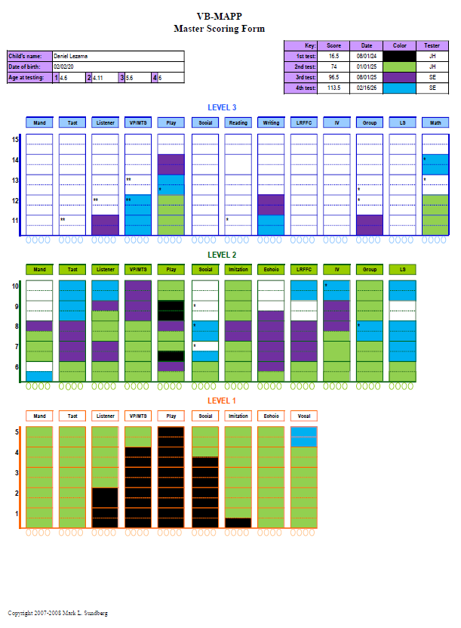
Figure 3: VBMAPP results for Daniel Lezama.

Behaviors Targeted for Reduction:
- Goal: Daniel will reduce the rate of tantrums to 0 per hour per session across 10 sessions. January 2026
- Goal: Daniel will reduce the rate of mouthing to no more than 0.5 per hour across one consecutive week. February 2026
- Goal: Daniel will reduce physically disruptive behavior to no more than 2 occurrences per week across 2 consecutive weeks. January 2026
- Goal: Daniel will reduce the rate of dropping to no more than 0.25 per hour across one consecutive week. February 2026
- Goal: Daniel will reduce the rate of aggression to no more than 0.5 per hour across one consecutive week. February 2026
Domain: Replacement Behavior:
- Goal: Daniel will wait for a preferred item or activity for up to 3 minutes in the absence of maladaptive behaviors in 80% of opportunities across 3 consecutive sessions. December 2025
Domain: Communication:
- Goal: Daniel will mand for at least 10 different missing items without prompts in 100% of opportunities across 3 consecutive sessions. November 2025
- Goal: Daniel will tact 50 noun-verb or verb-noun combinations with 100% accuracy across 3 consecutive sessions. February 2026
- Goal: Daniel will tact 200 nouns or verbs with 100% accuracy across 3 consecutive sessions. February 2026
- Goal: Daniel will answer 25 different who/where questions with 100% accuracy across 3 consecutive sessions. January 2026
- Goal: Daniel will match non-identical items in a messy array of 10 with 3 similar stimuli in 100% of opportunities across 3 consecutive sessions. February 2026
Domain: Learning Readiness
- Goal: Daniel will stay in a line (i.e. behind a peer) and transition to another location without prompting in 80% of opportunities across 3 consecutive sessions. February 2026
- Goal: Daniel will transition between classroom activities with no more than 1 gestural or verbal prompt in 80% of opportunities across 5 consecutive sessions. January 2026
- Goal: Daniel will select the correct item in a book, picture scene or natural environment when named for 250 items in 100% of opportunities across 3 consecutive sessions. February 2026
- Goal: Daniel will imitate 5 different writing actions modeled by an adult in 100% of opportunities across 3 consecutive sessions. November 2025
- Goal: Daniel will identify 8 different comparisons involving measurement in 100% of opportunities across 3 consecutive sessions. January 2026
- Goal: Daniel will fill out a “my day” sheet to answer questions about his day independently and accurately in 100% of opportunities across 3 consecutive sessions. October 2025
Domain: Social/Play Skills
- Goal: Daniel will engage in sustained social play with peers for a duration of 3 minutes without adult prompts across 3 consecutive sessions. December 2025
- Goal: Daniel will independently engage in arts and crafts type activities for a duration of 2 minutes across 3 consecutive sessions. January 2026
Domain: Adaptive Skills
- Goal: Daniel will independently gather personal items (i.e. go get your lunch, go grab glue, etc.) with no more than 1 verbal prompt across 3 different scenarios in 100% of opportunities across 3 consecutive sessions. December 2025
- Goal: Daniel will request the bathroom without having an accident with 100% accuracy across 3 consecutive sessions. January 2026

Domain: Caregiver Education
- Goal: Daniel’s caregivers will implement an adaptive skills protocol with 80% fidelity per BCBA report across 2 parent training opportunities. December 2025
- Goal: Daniel’s caregivers will prompt social communication skills (i.e. turn taking during conversations, answering ‘wh’ questions, etc.) with 80% fidelity per BCBA report across 2 parent training opportunities. December 2025

Overview of Goals and Progress:

Behaviors Targeted for Reduction:

- Goal: Daniel will reduce the rate of elopements to no more than 0.25 time per hour across 5 consecutive sessions.
Source: Functional Behavior Assessment
Location: Clinic
Medical Necessity:
- Related to characteristics consistent with DSM-5 diagnostic criteria for autism in the area of persistent deficits in social communication and social interaction including the following:
  - Deficits in social-emotional reciprocity
  - Deficits in nonverbal communicative behaviors used for social interaction
  - Deficits in developing, maintaining, and understanding relationships
- Behavior poses a safety risk for self and/or others
Operational Definition: Any attempt or success at walking or running away from a designated area more than 6 feet away from an adult.
Hypothesized Function: Escape maintained, access to tangible
Antecedent Based Strategies:
- Functional communication training – teach Daniel to request items and to request to end non-preferred activities using vocalizations
- Choices – provide Daniel with choices throughout the day
- First-then language – use first-then language when giving demands, such as first we will do your work, then we’ll blow bubbles
- Priming-Priming involves preparing the child for upcoming events, transitions, and situations. A visual schedule and timer are currently utilized daily.
- Token system (calendar and group work)
- Environmental arrangements- Altering the physical environment to reduce the likelihood of challenging behavior and increase the instructor’s ability to develop and maintain stimulus control (i.e. keeping doors closed, body positioning, removing preferred items from client’s environment).
Consequence Based Strategies:
- Access function- Attempt to redirect the tantrum and prompt Daniel to use functional communication to request the item when he is calm
- Escape from demands function- follow through with the demand; prompt functional communication
- Response blocking
Replacement Behavior(s):
- Daniel will tolerate a denied access protocol
- Daniel will tolerate the removal of preferred items
- Daniel will tolerate transitions to non-preferred activities
- Danial will tolerate waiting for preferred item/activities
- Daniel will wait or stop before leaving a designated area when directed verbally by staff
- Daniel will use functional communication to access wants and needs
Baseline Data: September 2024: Daniel engages in elopement an average rate of 2.09 times per hour across 5 ABA session.
Current Data: Daniel engages in elopement at an average rate of 0.35 times per hour.
Date Introduced: August 2025
Projected Mastery Date: 6 months
Progress:
- Recommendation: Continue
- Daniel is currently engaging in elopement at an average rate of 0.35 per hour. Daniel was able to decrease engagement in elopement by 55% since the previous treatment plan and make progress towards this goal. Daniel is most likely to elope when there is something in another room he wants, or in the afternoon during moments of downtime. When Daniel elopes, staff provide as little attention to the behavior as possible and guide Daniel back to the original location to request the item he was eloping for if appropriate.

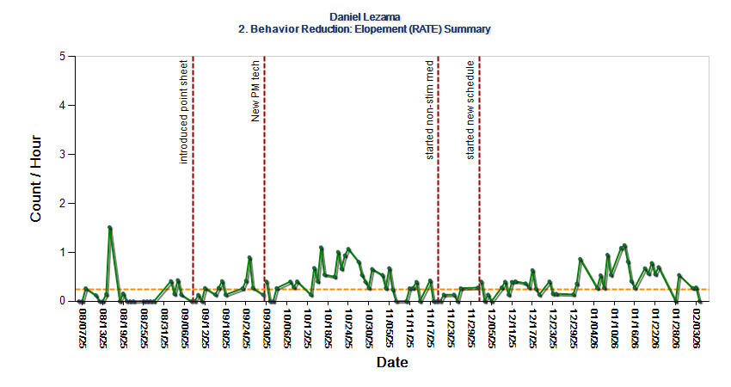
Figure 4: Count per hour of elopement for Daniel Lezama.

Skill Acquisition Goals:

Domain: Replacement Behaviors
- Goal: Daniel will tolerate denied access to items/activities in 80% of opportunities for 2 consecutive weeks.
Source: Functional Behavior Assessment
Treatment Setting(s): Clinic
Medical Necessity:
Related to characteristics consistent with DSM-5 diagnostic criteria for autism in the area of persistent deficits in social communication and social interaction including the following:
  - Deficits in social-emotional reciprocity
  - Deficits in nonverbal communicative behaviors used for social interaction
  - Deficits in developing, maintaining, and understanding relationships
- Related to characteristics consistent with DSM-5 diagnostic criteria for autism in the area of restricted, repetitive patterns of behavior, interests, or activities as evidenced by the following:
  - Stereotyped or repetitive motor movements, use of objects or speech
  - Insistence on sameness, inflexible adherence to routines, or ritualized patterns of behavior
  - Highly restricted, fixated interests that are abnormal in intensity or focus
  - Hyper- or hypo-reactivity to sensory input or unusual interest in sensory aspects of the environment
- Skill is a replacement behavior for safety concern identified
Baseline Data: September 2024: Daniel currently tolerates denied access in 0% of opportunities.
Current Data: August 2025: Daniel tolerates denied access in 63% of opportunities.
Date Introduced: September 2024
Current Targets: Tolerating denied access to items/activities
Targets Mastered: N/A
Projected Mastery Date: 6 months
Progress:
- Recommendation: Continue
- During this treatment period, Daniel demonstrated the ability to tolerate denied access without engaging in maladaptive behaviors in an average of 63% of opportunities. Data was averaged across the last 6-month treatment period. Daniel often struggles to tolerate denied access when he is directed to transition from preferred to nonpreferred activities or if he has to wait for a preferred activity/item. More recently, Daniel has been struggling with denied access to completing routines and ‘imperfections’ in the environment (i.e. given a broken piece of food, missing a puzzle piece, a number being drawn in the wrong color, etc.). The graph below depicts variability in data. Variability in data may be explained by the specific items or activities Daniel is denied access to in a session. During the upcoming treatment period, Daniel will continue to be offered other preferred choices when he is denied access to an item.
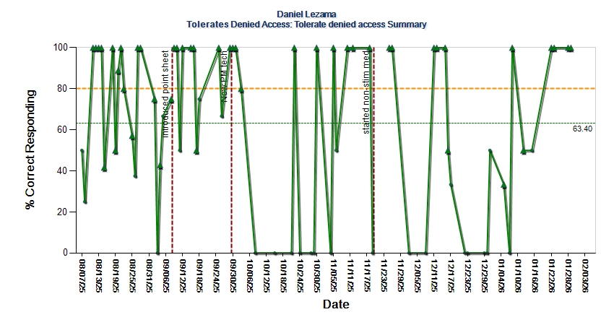
Figure 5: Percent correct responding for tolerating denied access for Daniel Lezama.

- Goal: Daniel will wait or stop before leaving a designated area when directed verbally by staff on 80% of opportunities across one consecutive week.
Source: Clinical observation
Treatment Setting(s): Clinic
Medical Necessity: Related to characteristics consistent with DSM-5 diagnostic criteria for autism in the area of persistent deficits in social communication and social interaction including the following:
  - Deficits in social-emotional reciprocity
  - Deficits in nonverbal communicative behaviors used for social interaction
  - Deficits in developing, maintaining, and understanding relationships
Baseline Data: January 2025: Daniel waits or stops before leaving a designated area when directed verbally by staff on 0% of opportunities.
Date Introduced: January 2025
Current Targets: Wait or stop before leaving a designated area when directed verbally by staff
Mastered Targets: N/A
Projected Mastery Date: 6 months
Progress:
- Recommendation: Continue
- Daniel’s motivation to wait/stop when directed is variable from day to day. This may be in part due to peers behavior, or specific items he may be leaving the location for. In the upcoming treatment period, Daniel will be given special reinforcement such as an edible for complying with this direction specifically when his peers are engaging in elopement. If Daniel is leaving the location to access an item elsewhere, access to the item is blocked and functional communication is prompted/reinforced.
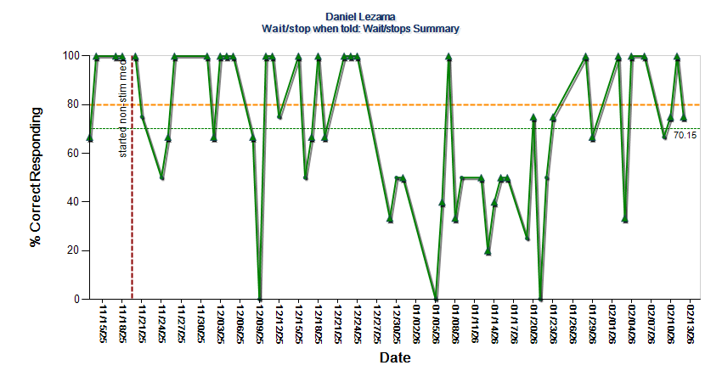
Figure 6: Percent correct responding for waiting/stopping when told for Daniel Lezama

Domain: Communication

- Goal: Daniel will tact the color, shape and function of 5 different objects (15 trials) with 100% accuracy across 3 sessions.
Source: VBMAPP Tact 11
Treatment Setting(s): Clinic
Medical Necessity: Related to characteristics consistent with DSM-5 diagnostic criteria for autism in the area of persistent deficits in social communication and social interaction including the following:
  - Deficits in social-emotional reciprocity
  - Deficits in nonverbal communicative behaviors used for social interaction
  - Deficits in developing, maintaining, and understanding relationships
Baseline Data: August 2025: Daniel can tact the color of different objects, but does not tact shape or function consistently.
Date Introduced: August 2025
Current Targets: pillow, football
Targets Mastered: chip
Projected Goal Mastery: 6 months
Progress:
- Recommendation: Continue
- This goal has been an area of difficulty for Daniel due to inattention to the vocal discriminative stimulus. When presented with the picture, Daniel will tact the item and then struggles to answer with the correct feature when asked in a rotating order. This goal will continue to be targeted in the upcoming treatment period. Additional prompting will be built into each question and faded out with success to aid in Daniel’s mastery of this goal.

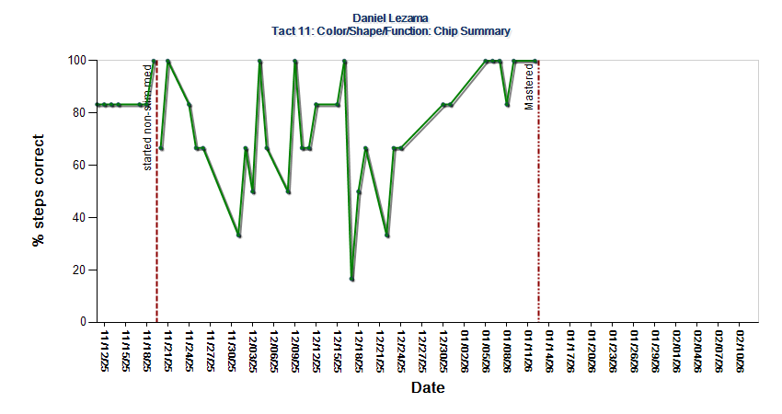
Figure 7: Percent steps correct for tacting color/shape/function of Chip for Daniel Lezama
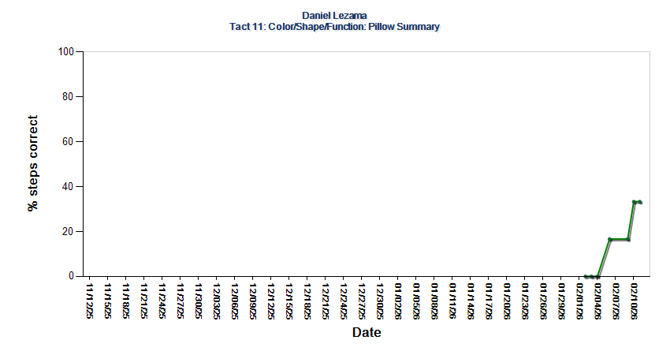
Figure 8: Percent steps correct for tacting color/shape/function of pillow for Daniel Lezama

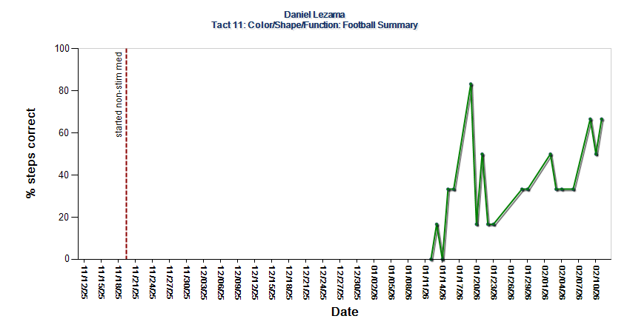
Figure 9: Percent steps correct for tacting color/shape/function of football for Daniel Lezama

- Goal: Daniel will demonstrate 200 different intraverbal responses with 100% accuracy across 3 consecutive sessions.
Source: VBMAPP IV 12
Treatment Setting(s): Clinic
Medical Necessity: Related to characteristics consistent with DSM-5 diagnostic criteria for autism in the area of persistent deficits in social communication and social interaction including the following:
  - Deficits in social-emotional reciprocity
  - Deficits in nonverbal communicative behaviors used for social interaction
  - Deficits in developing, maintaining, and understanding relationships
Baseline Data: August 2025: Daniel currently answers 51 intraverbal questions.
Date Introduced: August 2025
Current Targets: 5
Targets Mastered: 81
Projected Goal Mastery: 6 months
Progress:
- Recommendation: Continue
- Daniel has been making steady progress towards this goal and has acquired 30 new responses this treatment period. BCBA is tracking data for this goal anecdotally. This goal area will continue to be targeted in the upcoming treatment period.

Domain: Learning Readiness

- Goal: Daniel will complete 20 different block designs, or similar tasks that involve 8 or more pieces in 100% of opportunities across 3 consecutive sessions.
Source: VBMAPP VP MTS 13
Treatment Setting(s): Clinic
Medical Necessity: Related to characteristics consistent with DSM-5 diagnostic criteria for autism in the area of persistent deficits in social communication and social interaction including the following:
  - Deficits in social-emotional reciprocity
  - Deficits in nonverbal communicative behaviors used for social interaction
  - Deficits in developing, maintaining, and understanding relationships
Baseline Data: August 2025: Daniel completes a block design in 0% of opportunities.
Date Introduced: January 2026
Current Targets: 2
Targets Mastered: 0
Projected Goal Mastery 6 months
Progress:
- Recommendation: Continue
- Daniel has been working on the prerequisite skill of this goal, assembling 4 or more pieces and has mastered 5 designs so far. This goal will continue to be targeted in the upcoming treatment period.
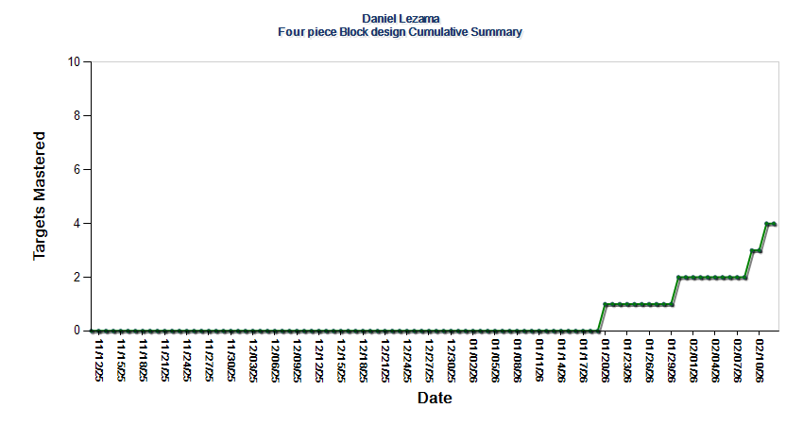

Figure 10: Cumulative summary of 4-piece block design targets mastered for Daniel Lezama.

- Goal: Daniel will follow directions involving 6 different prepositions and 4 different pronouns in 100% of opportunities across 3 consecutive sessions.
Source: VBMAPP Listener 12
Treatment Setting(s): Clinic
Medical Necessity: Related to characteristics consistent with DSM-5 diagnostic criteria for autism in the area of persistent deficits in social communication and social interaction including the following:
  - Deficits in social-emotional reciprocity
  - Deficits in nonverbal communicative behaviors used for social interaction
  - Deficits in developing, maintaining, and understanding relationships
Baseline Data: August 2025: Daniel currently follows directions involving 2 prepositions (“on top of” and “in”) and 2 pronouns (“my” and “yours”).
Date Introduced: August 2025
Current Targets: 2
Targets Mastered: 6
Projected Goal Mastery: 6 months
Progress
- Recommendation: Continue
- This goal has been an area of difficulty for Daniel. Several different strategies have been trialed with varying levels of success such as varying materials, stimulus prompting (i.e. preposition mat), and trialing building tacting prepositions prior. Currently, Daniel is working on prepositional targets with a motor response (i.e. standing behind chair). This goal will continue to be targeted in the upcoming treatment period.
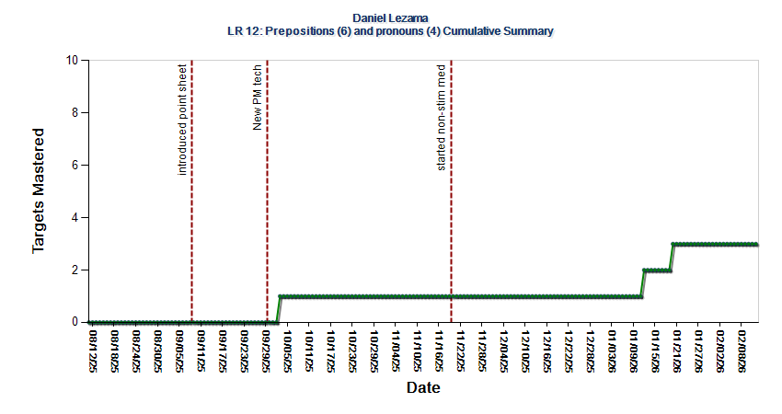
Figure 11: Cumulative summary of listener responding prepositions and pronouns for Daniel Lezama.

- Goal: Daniel will select the correct item from an array of 10 given 3 verbal statements about each item when independently presented for 25 items with 100% accuracy across 3 consecutive sessions.
Source: VBMAPP LRFFC 9
Treatment Setting(s): Clinic
Medical Necessity: Related to characteristics consistent with DSM-5 diagnostic criteria for autism in the area of persistent deficits in social communication and social interaction including the following:
  - Deficits in social-emotional reciprocity
  - Deficits in nonverbal communicative behaviors used for social interaction
  - Deficits in developing, maintaining, and understanding relationships
Baseline Data: June 2025: Daniel select the correct item from an array of 10 given 3 verbal statements about each item with 0% accuracy.
Date Introduced: June 2025
Current Targets: 3
Targets Mastered: 46
Projected Goal Mastery: 6 months
Progress:
- Recommendation: Continue
- Daniel has been making steady progress towards this goal since introduction. This goal will continue to be targeted in the upcoming treatment period.
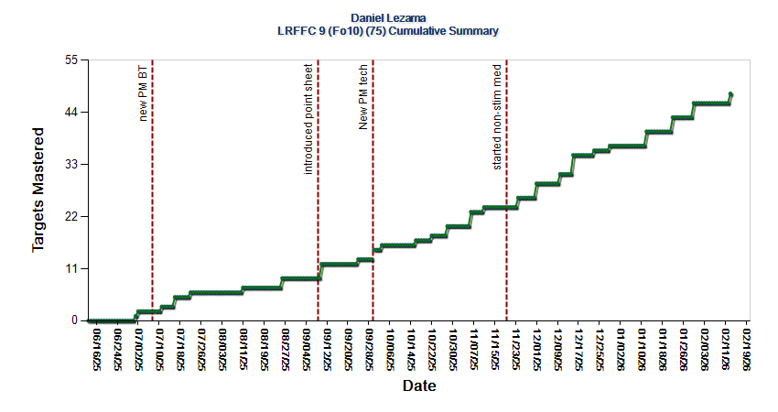

Figure 12: Cumulative summary of LRFFC 9 targets mastered for Daniel Lezama.

Domain: Social Skills

- Goal: Daniel will respond to adult and peer greetings by waving and/or saying “hi” in 80% of opportunities across 3 consecutive sessions.
Source: Clinical observation
Treatment Setting(s): Clinic
Medical Necessity:
Related to characteristics consistent with DSM-5 diagnostic criteria for autism in the area of persistent deficits in social communication and social interaction including the following:
  - Deficits in social-emotional reciprocity
  - Deficits in nonverbal communicative behaviors used for social interaction
  - Deficits in developing, maintaining, and understanding relationships
Baseline Data: September 2024: Daniel responds to adult and peer greetings in 0% of opportunities.
Current Data: February 2026: Daniel responds to adult greetings in 68% of opportunities and peer greetings in 23% of opportunities.
Date Introduced: September 2024
Current Targets: Respond to adult and peer greetings by waving and/or saying “hi”
Targets Mastered: N/A
Projected Mastery Date: 6 months
Progress:
- Recommendation: Continue
- Daniel is currently working on responding to greetings from adults and peers. He demonstrates the ability to respond to greetings from adults without prompting in 68% of opportunities and peers in 23% of opportunities. Daniel sometimes requires a verbal or gestural prompt to greet adults once they have initiated the interaction. Daniel is more successful with responding when the communication partner is in his line of sight and in close proximity. To assist with mastery of this goal, when Daniel independently responds to greetings from adults and peers he will be reinforced with an edible. This goal will be continued in the upcoming treatment period.
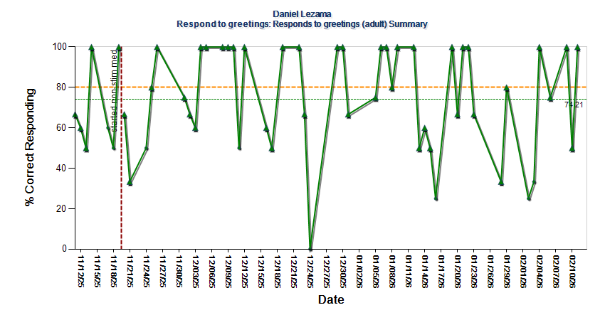

Figure 13: Percent correct responding for responding to adult greetings for Daniel Lezama.
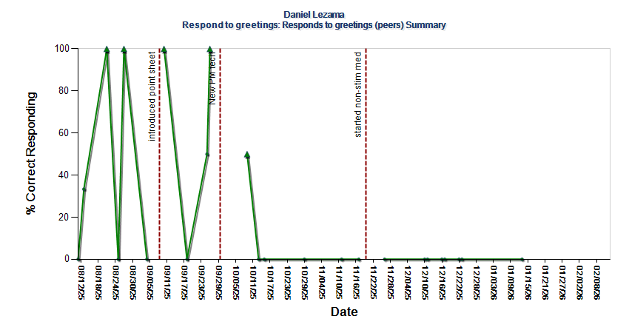
Figure 14: Percent correct responding for responding to peer greetings for Daniel Lezama.

- Goal: Daniel will mand to peers without prompting from a technician at least 2 times per session across 3 consecutive sessions.
Source: VBMAPP Social 7
Treatment Setting(s): Clinic
Medical Necessity: Related to characteristics consistent with DSM-5 diagnostic criteria for autism in the area of persistent deficits in social communication and social interaction including the following:
  - Deficits in social-emotional reciprocity
  - Deficits in nonverbal communicative behaviors used for social interaction
  - Deficits in developing, maintaining, and understanding relationships
Baseline Data: January 2025: Daniel currently mand to peers without prompting from a technician 0 times per session.
Current Data: February 2026: Daniel currently mands to peers without prompting from a technician an average of .6 times per session.
Date Introduced: January 2025
Current Targets: 1
Mastered Targets: 0
Projected Mastery Date: 6 months
Progress:
- Recommendation: Continue
- Daniel currently mands to peers without prompting from a technician an average of .6 times
per session. Daniel may be motivated to mand to a peer when a peer has a desired tangible item. Staff currently provide physical blocking to prevent grabbing the peer’s item and redirect Daniel to request the item with a verbal prompt.
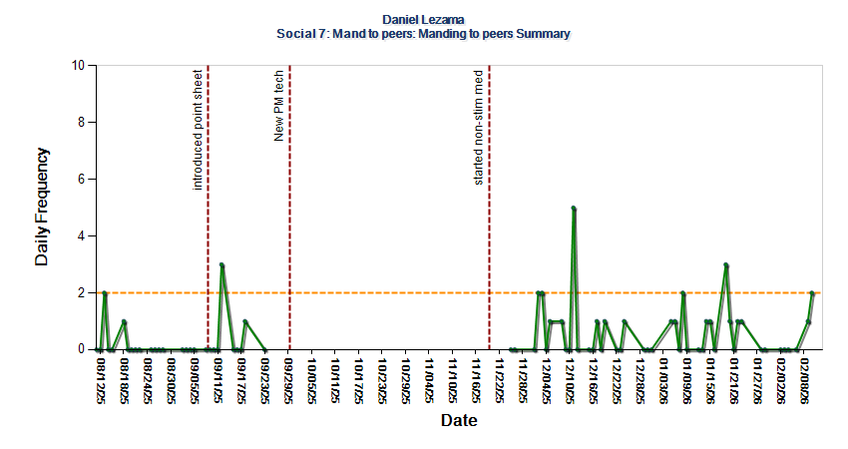
Figure 15: Daily frequency of manding to peers for Daniel Lezama.

- Goal: Daniel will independently respond to the mands of peers 5 times across 3 consecutive sessions.
Source: VBMAPP Social 9
Treatment Setting(s): Clinic
Medical Necessity: Related to characteristics consistent with DSM-5 diagnostic criteria for autism in the area of persistent deficits in social communication and social interaction including the following:
  - Deficits in social-emotional reciprocity
  - Deficits in nonverbal communicative behaviors used for social interaction
  - Deficits in developing, maintaining, and understanding relationships
Baseline Data: August 2025: Daniel currently responds to mands from peers without prompting from a technician 0 times per session.
Current Data: February 2026: Daniel responds to the mands of peers without prompting from a technician an average of .6 times per session.
Date Introduced: September 2025
Current Targets: 1
Mastered Targets: 0
Projected Mastery Date: 6 months
Progress:
- Recommendation: Continue
- This goal has been an area of difficulty for Daniel. Daniel typically needs a prompt from his technician to respond to mands from peers. Daniel seems to want to engage with his peers, and will look in their direction and smile, but is hesitant to engage. When Daniel responds to his peers mands, he receives high quality, enthusiastic praise. This goal will continue to be targeted in the upcoming treatment period.
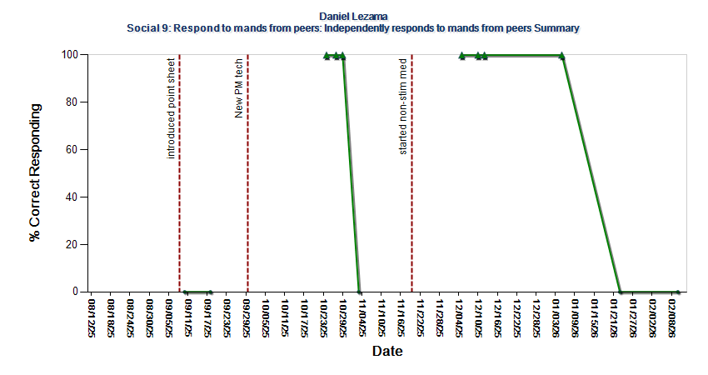

Figure 16: Percent correct responding for responding to mands from peers for Daniel Lezama

Domain: Group Skills

- Goal: Daniel will respond to 5 different group instructions or questions without direct prompts in a group of 3 or more children across 3 consecutive sessions.
Source: VBMAPP Group 12
Treatment Setting(s): Clinic
Medical Necessity: Related to characteristics consistent with DSM-5 diagnostic criteria for autism in the area of persistent deficits in social communication and social interaction including the following:
  - Deficits in social-emotional reciprocity
  - Deficits in nonverbal communicative behaviors used for social interaction
  - Deficits in developing, maintaining, and understanding relationships
Baseline Data: January 2025: Daniel currently responds to an average of 1 group instruction or question without direct prompts in a group setting.
Current Data: February 2026: Daniel currently responds to an average of 1 group instruction or question without direct prompts in a group setting, with a range of 0-6.
Date Introduced: January 2025
Current Targets: 1
Mastered Targets: 0
Projected Mastery Date: 6 months
Progress:
- Recommendation: Continue
- This is an area of difficulty for Daniel. He is most likely to be successful with this goal if the instruction or question comes from a behavior technician he commonly works with. If Daniel doesn’t respond to the whole group instruction, the behavior technician working with him will provide verbal or gestural prompting to que him to respond to the instruction. In the upcoming treatment period, an edible reinforcer will be used to reinforce Daniel’s independent responding to group instructions without requiring prompting from his tech.

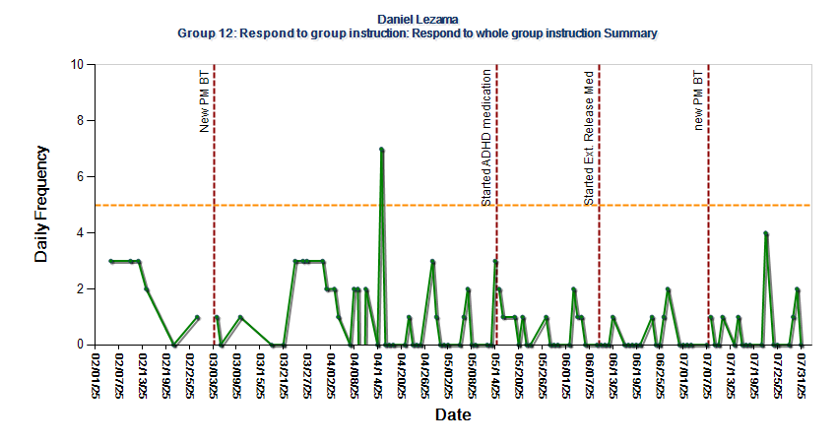
Figure 17: Daily frequency of responding to whole group instructions for Daniel Lezama.

Domain: Adaptive Skills

- Goal: Daniel will independently complete a lace tying routine in 80% of opportunities across 5 consecutive sessions.
Source: Caregiver Report
Treatment Setting(s): Clinic
Medical Necessity:
- Related to characteristics consistent with DSM-5 diagnostic criteria for autism in the area of persistent deficits in social communication and social interaction including the following:
  - Deficits in social-emotional reciprocity
  - Deficits in nonverbal communicative behaviors used for social interaction
  - Deficits in developing, maintaining, and understanding relationships
Baseline Data: August 2025: Daniel ties laces independently in 0% of opportunities.
Date Introduced: October 2025
Current Targets: 1
Targets Mastered: n/a
Projected Goal Mastery: 6 months
Progress:
- Recommendation: Continue
- Daniel has made minimal progress within this goal over the previous treatment period. Currently, he is working on the second step of a forward chaining procedure. A backwards chaining procedure was trialed previously with no success. If Daniel is not successful with the forward chaining procedure, within stimulus prompts such as colored tape on each lace will be added.
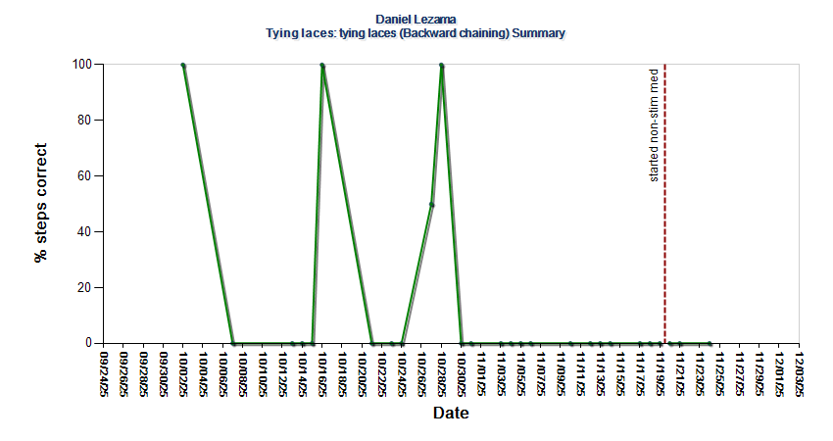

Figure 18: Percent steps correct for tying laces for Daniel Lezama via backward chaining.
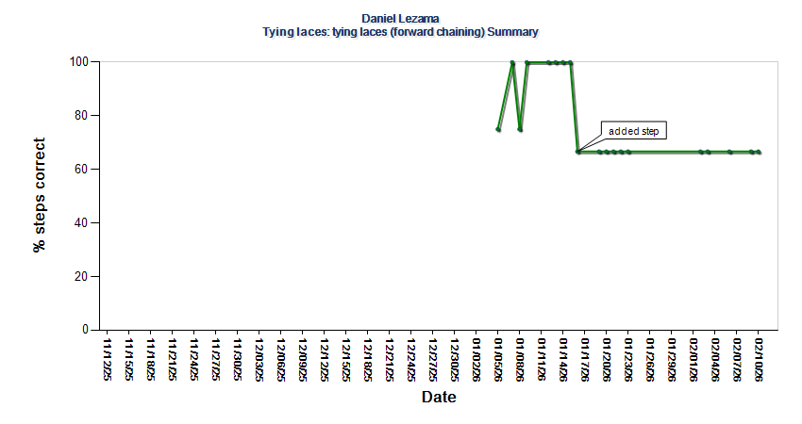
Figure 19: Percent steps correct for tying laces for Daniel Lezama via forward chaining.

Proposed Goals:

Behaviors Targeted for Reduction:

- Goal: Daniel will reduce the rate of tantrums to 0 per hour per session across one month.
Source: Functional Behavior Assessment
Location: Clinic
Medical Necessity:
- Related to characteristics consistent with DSM-5 diagnostic criteria for autism in the area of persistent deficits in social communication and social interaction including the following:
  - Deficits in social-emotional reciprocity
  - Deficits in nonverbal communicative behaviors used for social interaction
  - Deficits in developing, maintaining, and understanding relationships
- Behavior poses a safety risk for self and/or others
Operational Definition: a period of crying or screaming for 30 seconds or more with an offset of 1 minute.
Hypothesized Function: Escape maintained, access to tangible, attention
Baseline Data: August 2024; caregivers report Daniel engages in tantrums on average 2 times a week
Current Data: February 2026: Daniel engages in tantrums an average frequency of .01 times per hour
Projected Introduction Date: February 2026
Projected Mastery Date: 6 months
Antecedent Based Strategies:
- Functional communication training – teach Daniel to request items and to request to end non-preferred activities using vocalizations
- Choices – provide Daniel with choices throughout the day
- First-then language – use first-then language when giving demands, such as first we will do your work, then we’ll blow bubbles
- Priming-Priming involves preparing the child for upcoming events, transitions, and situations. A visual schedule and timer are currently utilized daily.
- Token system (calendar and group work)
Consequence Based Strategies:
- Access function- Attempt to redirect the tantrum and prompt Daniel to use functional communication to request the item when he is calm
- Escape from demands function- follow through with the demand; prompt functional communication
- Attention function- Provide no positive or negative attention
Replacement Behavior(s):
- Daniel will tolerate a denied access protocol
- Daniel will tolerate the removal of preferred items
- Daniel will tolerate transitions to non-preferred activities
- Danial will tolerate waiting for preferred item/activities
- Daniel will use functional communication to access wants and needs

- Goal: Daniel will reduce the rate of mouthing to no more than 0.5 per hour across one consecutive week.
Source: Functional Behavior Assessment
Location: Clinic
Medical Necessity:
- Related to characteristics consistent with DSM-5 diagnostic criteria for autism in the area of persistent deficits in social communication and social interaction including the following:
  - Deficits in social-emotional reciprocity
  - Deficits in nonverbal communicative behaviors used for social interaction
  - Deficits in developing, maintaining, and understanding relationships
- Behavior poses a safety risk for self and/or others
Operational Definition: Any instance of placing a non-edible item inside his mouth.
Hypothesized Function: Automatic
Baseline Data: August 2024: Daniel engaged in 6 instances of mouthing during a 45-minute observation.
Current Data: February 2026: Daniel engages in mouthing an average of 0.5 times per hour
Projected Introduction Date: February 2026
Projected Mastery Date: 6 months
Antecedent Based Strategies:
- Environmental arrangements- Altering the physical environment to reduce the likelihood of challenging behavior and increase the instructor’s ability to develop and maintain stimulus control (i.e. keeping items that Daniel normally mouths out of reach).
Consequence Based Strategies:
- Automatic function- Block and redirect mouthing occurrences
- Response blocking
- Redirection- Redirection involves using a prompt to direct a client’s behavior to a more appropriate behavior (i.e. chew).
Replacement Behavior(s):
- Daniel will engage in a functionally appropriate behavior that is incompatible with mouthing (i.e. using chew).

- Goal: Daniel will reduce the rate of aggression to no more than 0.25 per hour across one consecutive week.
Source: Functional Behavior Assessment
Location: Clinic
Medical Necessity:
- Related to characteristics consistent with DSM-5 diagnostic criteria for autism in the area of persistent deficits in social communication and social interaction including the following:
  - Deficits in social-emotional reciprocity
  - Deficits in nonverbal communicative behaviors used for social interaction
  - Deficits in developing, maintaining, and understanding relationships
- Behavior poses a safety risk for self and/or others
Operational Definition: Any instance or attempt of hitting, biting, and/or pulling hair/clothing.
Hypothesized Function: Escape maintained, access to tangible, attention
Baseline Data: September 2024: Daniel engages in aggressions an average rate of 2.15 times per hour across 5 ABA sessions
Current Data: February 2026: Daniel engages in aggressions an average rate of 0.5 times per hour
Projected Introduction Date: February 2026
Projected Mastery Date: 6 months
Antecedent Based Strategies:
- Functional communication training – teach Daniel to request items and to request to end non-preferred activities using vocalizations
- Choices – provide Daniel with choices throughout the day
- First-then language – use first-then language when giving demands, such as first we will do your work, then we’ll blow bubbles
- Priming-Priming involves preparing the child for upcoming events, transitions, and situations. A visual schedule and timer are currently utilized daily.
- Token system (calendar and group work)
Consequence Based Strategies:
- Access function- Attempt to redirect the tantrum and prompt Daniel to use functional communication to request the item when he is calm
- Escape from demands function- follow through with the demand; prompt functional communication
- Attention function- Provide no positive or negative attention
- Response blocking
Replacement Behavior(s):
- Daniel will tolerate a denied access protocol
- Daniel will tolerate the removal of preferred items
- Daniel will tolerate transitions to non-preferred activities
- Danial will tolerate waiting for preferred item/activities
- Daniel will use functional communication to access wants and needs

- Goal: Daniel will reduce physically disruptive behavior to no more than 0.25 times per hour across 5 consecutive sessions.
Source: Functional Behavior Assessment
Location: Clinic
Medical Necessity:
- Related to characteristics consistent with DSM-5 diagnostic criteria for autism in the area of persistent deficits in social communication and social interaction including the following:
  - Deficits in social-emotional reciprocity
  - Deficits in nonverbal communicative behaviors used for social interaction
  - Deficits in developing, maintaining, and understanding relationships
- Behavior poses a safety risk for self and/or others
Operational Definition: any instance of tipping, throwing, or pushing over furniture.
Hypothesized Function: Escape maintained, access to tangible, attention
Baseline Data: December 2024: Daniel engages in physical disruption an average rate of 1.02 times per hour across 5 ABA sessions
Current Data: February 2026: Daniel engages in physical disruption an average rate of 0.5 times per hour or 20 per week.
Projected Introduction Date: February 2026
Projected Mastery Date: 6 months
Antecedent Based Strategies:
- Functional communication training – teach Daniel to request items and to request to end non-preferred activities using vocalizations
- Choices – provide Daniel with choices throughout the day
- First-then language – use first-then language when giving demands, such as first we will do your work, then we’ll blow bubbles
- Priming-Priming involves preparing the child for upcoming events, transitions, and situations. A visual schedule and timer are currently utilized daily.
- Token system (calendar and group work)
Consequence Based Strategies:
- Access function- Attempt to redirect the tantrum and prompt Daniel to use functional communication to request the item when he is calm
- Escape from demands function- follow through with the demand; prompt functional communication
- Attention function- Provide no positive or negative attention
- Response blocking
Replacement Behavior(s):
- Daniel will tolerate a denied access protocol
- Daniel will tolerate the removal of preferred items
- Daniel will tolerate transitions to non-preferred activities
- Danial will tolerate waiting for preferred item/activities
- Daniel will use functional communication to access wants and needs

- Goal: Daniel will reduce the rate of dropping to no more than 5 per week across one consecutive week.
Source: Functional Behavior Assessment
Location: Clinic
Medical Necessity:
- Related to characteristics consistent with DSM-5 diagnostic criteria for autism in the area of persistent deficits in social communication and social interaction including the following:
  - Deficits in social-emotional reciprocity
  - Deficits in nonverbal communicative behaviors used for social interaction
  - Deficits in developing, maintaining, and understanding relationships
- Behavior poses a safety risk for self and/or others
Operational Definition: Any instance of Daniel dropping his body to the floor following a demand or denied access from staff.
Hypothesized Function: Escape maintained, access to tangible
Baseline Data: September 2024: Daniel engages in aggressions an average rate of 1.80 times per hour across 5 ABA sessions
Current Data: February 2026: Daniel engages in dropping an average rate of 0.25 times per hour or 10 times per week.
Projected Introduction Date: Immediately
Projected Mastery Date: 6 months
Antecedent Based Strategies:
- Functional communication training – teach Daniel to request items and to request to end non-preferred activities using vocalizations
- Choices – provide Daniel with choices throughout the day
- First-then language – use first-then language when giving demands, such as first we will do your work, then we’ll blow bubbles
- Priming-Priming involves preparing the child for upcoming events, transitions, and situations. A visual schedule and timer are currently utilized daily.
- Token system (calendar and group work)
Consequence Based Strategies:
- Access function- Attempt to redirect the tantrum and prompt Daniel to use functional communication to request the item when he is calm
- Escape from demands function- follow through with the demand; prompt functional communication
Replacement Behavior(s):
- Daniel will tolerate a denied access protocol
- Daniel will tolerate the removal of preferred items
- Daniel will tolerate transitions to non-preferred activities
- Danial will tolerate waiting for preferred item/activities
- Daniel will use functional communication to access wants and needs

- Goal: Daniel will reduce the rate of self-injury to no more than 4 per week across one consecutive week.
Source: Functional Behavior Assessment
Location: Clinic
Medical Necessity:
- Related to characteristics consistent with DSM-5 diagnostic criteria for autism in the area of persistent deficits in social communication and social interaction including the following:
  - Deficits in social-emotional reciprocity
  - Deficits in nonverbal communicative behaviors used for social interaction
  - Deficits in developing, maintaining, and understanding relationships
- Behavior poses a safety risk for self and/or others
Operational Definition: Any instance of Daniel dropping his body to the floor following a demand or denied access from staff.
Hypothesized Function: Escape maintained, access to tangible
Baseline Data: February 2026: Daniel engages in self-injury an average rate of 8 times per hour across one week of ABA sessions
Projected Introduction Date: February 2026
Projected Mastery Date: 6 months
Antecedent Based Strategies:
- Functional communication training – teach Daniel to request items and to request to end non-preferred activities using vocalizations
- Choices – provide Daniel with choices throughout the day
- First-then language – use first-then language when giving demands, such as first we will do your work, then we’ll blow bubbles
- Priming-Priming involves preparing the child for upcoming events, transitions, and situations. A visual schedule and timer are currently utilized daily.
- Token system (calendar and group work)
Consequence Based Strategies:
- Block engagement in self-injury by placing a soft surface on the hard surface Daniel is attempting to bang his head on
- Access function- Attempt to redirect the self-injury and prompt Daniel to use functional communication to request the item when he is calm
- Escape from demands function- follow through with the demand; prompt functional communication
Replacement Behavior(s):
- Daniel will tolerate a denied access protocol
- Daniel will tolerate the removal of preferred items
- Daniel will tolerate transitions to non-preferred activities
- Danial will tolerate waiting for preferred item/activities
- Daniel will use functional communication to access wants and needs

Domain: Replacement Behavior

- Goal: Daniel will request to retrieve a desired item in the absence of elopement in 80% of opportunities across 3 consecutive sessions.
Source: Clinical observation
Treatment Setting(s): Clinic
Medical Necessity: Related to characteristics consistent with DSM-5 diagnostic criteria for autism in the area of persistent deficits in social communication and social interaction including the following:
  - Deficits in social-emotional reciprocity
  - Deficits in nonverbal communicative behaviors used for social interaction
  - Deficits in developing, maintaining, and understanding relationships
- Behavior poses a safety risk for self and others.
Baseline Data: February 2026: Daniel requests prior to retrieving desired item in the absence of elopement in 0% of opportunities.
Projected Introduction Date: February 2026
Projected Mastery Date: 6 months

Domain: Communication Skills

- Goal: Daniel will increase his variety of 3+ word mands to 15 with 100% accuracy across 3 consecutive sessions.
Source: Clinic Observation
Medical Necessity: Related to characteristics consistent with DSM-5 diagnostic criteria for autism in the area of persistent deficits in social communication and social interaction including the following:
  - Deficits in social-emotional reciprocity
  - Deficits in nonverbal communicative behaviors used for social interaction
  - Deficits in developing, maintaining, and understanding relationships
Baseline Data: Daniel has 2 mands with 3+ words with 100% accuracy.
Projected Introduction Date: February 2026
Projected Goal Mastery: 6 months

- Goal: Daniel will politely mand for others to stop an undesirable activity under 5 different circumstances in 80% of opportunities across 3 consecutive sessions.
Source: VB-MAPP Mand 12
Location: Clinic
Medical Necessity: Related to characteristics consistent with DSM-5 diagnostic criteria for autism in the area of persistent deficits in social communication and social interaction including the following:
  - Deficits in social-emotional reciprocity
  - Deficits in nonverbal communicative behaviors used for social interaction
  - Deficits in developing, maintaining, and understanding relationships
Baseline Data: February 2026: Daniel politely mands for others to stop an undesirable activity in 0 different circumstances.
Projected Introduction Date: February 2026
Projected Goal Mastery: 6 months

Domain: Learning Readiness

- Goal: Daniel will tact 4 different prepositions and 4 different pronouns in 80% of opportunities across 3 consecutive sessions.
Source: VB-MAPP Tact 12
Location: Clinic
Medical Necessity: Related to characteristics consistent with DSM-5 diagnostic criteria for autism in the area of persistent deficits in social communication and social interaction including the following:
  - Deficits in social-emotional reciprocity
  - Deficits in nonverbal communicative behaviors used for social interaction
  - Deficits in developing, maintaining, and understanding relationships
Baseline Data: February 2026: Daniel tacts prepositions and pronouns with 0% accuracy.
Introduction Date: February 2026
Projected Goal Mastery: 6 months

- Goal: Daniel will select items from an array of similar stimuli based on 4 pairs of relational adjectives and demonstrate actions based on 4 pairs of relational adverbs in 80% of opportunities across 3 consecutive sessions.
Source: VB-MAPP Listener Responding 13
Location: Clinic
Medical Necessity: Related to characteristics consistent with DSM-5 diagnostic criteria for autism in the area of persistent deficits in social communication and social interaction including the following:
  - Deficits in social-emotional reciprocity
  - Deficits in nonverbal communicative behaviors used for social interaction
  - Deficits in developing, maintaining, and understanding relationships
Baseline Data: February 2026: Daniel identifies 0 relational adjective pair and demonstrates actions based on one adverb pair.
Introduction Date: February 2026
Projected Goal Mastery: 6 months

- Goal: Daniel will follow 3 step directions in regards to classroom routines for 10 different directions in 80% of opportunities across 3 consecutive sessions.
Source: VB-MAPP Listener Responding 14
Location: Clinic
Medical Necessity: Related to characteristics consistent with DSM-5 diagnostic criteria for autism in the area of persistent deficits in social communication and social interaction including the following:
  - Deficits in social-emotional reciprocity
  - Deficits in nonverbal communicative behaviors used for social interaction
  - Deficits in developing, maintaining, and understanding relationships
Baseline Data: February 2026: Daniel follows 3 step directions in 0% of opportunities.
Projected Introduction Date: February 2026
Projected Goal Mastery: 6 months

- Goal: Daniel will select the correct item from a book, picture scene or environment given 4 different rotating LRFFC questions about a single topic for 25 different topics in 80% of opportunities across 3 consecutive sessions.
Source: VB-MAPP Listener Responding 14
Location: Clinic
Medical Necessity: Related to characteristics consistent with DSM-5 diagnostic criteria for autism in the area of persistent deficits in social communication and social interaction including the following:
  - Deficits in social-emotional reciprocity
  - Deficits in nonverbal communicative behaviors used for social interaction
  - Deficits in developing, maintaining, and understanding relationships
Baseline Data: February 2026: Daniel selects the correct item from a picture scene given 4 different rotating LRFFC questions for 15 different topics in 80% of opportunities.
Projected Introduction Date: February 2026
Projected Goal Mastery: 6 months

- Goal: After being read a short story, Daniel will answer 2 questions for 25 short stories in 80% of opportunities across 3 consecutive sessions.
Source: VB-MAPP Intraverbal 13
Location: Clinic
Medical Necessity: Related to characteristics consistent with DSM-5 diagnostic criteria for autism in the area of persistent deficits in social communication and social interaction including the following:
  - Deficits in social-emotional reciprocity
  - Deficits in nonverbal communicative behaviors used for social interaction
  - Deficits in developing, maintaining, and understanding relationships
Baseline Data: February 2026: Daniel answers questions after being read a short story in 0% of opportunities.
Projected Introduction Date: February 2026
Projected Goal Mastery: 6 months

Domain: Play Skills

- Goal: Daniel will independently draw/write in an activity book for 2 minutes in 80% of opportunities across 3 consecutive sessions.
Source: VB-MAPP Play 15
Location: Clinic
Medical Necessity: Related to characteristics consistent with DSM-5 diagnostic criteria for autism in the area of persistent deficits in social communication and social interaction including the following:
  - Deficits in social-emotional reciprocity
  - Deficits in nonverbal communicative behaviors used for social interaction
  - Deficits in developing, maintaining, and understanding relationships
Baseline Data: February 2026: Daniel independently draws/writes in an activity book in 0% of opportunities.
Projected Introduction Date: February 2026
Projected Goal Mastery: 6 months

Domain: Social Skills

- Goal: Daniel will engage in cooperative play at least 2 times a session across 3 consecutive sessions.
Source: VB-MAPP Social 11
Location: Clinic
Medical Necessity: Related to characteristics consistent with DSM-5 diagnostic criteria for autism in the area of persistent deficits in social communication and social interaction including the following:
  - Deficits in social-emotional reciprocity
  - Deficits in nonverbal communicative behaviors used for social interaction
  - Deficits in developing, maintaining, and understanding relationships
Baseline Data: February 2026: Daniel engages in cooperative play 0 times per session.
Projected Introduction Date: February 2026
Projected Goal Mastery: 6 months

- Goal: Daniel will share preferred items with peers without engaging in maladaptive behaviors
in 85% of opportunities for 5 consecutive sessions.
Source: Clinician Observation
Treatment Setting(s): Clinic
Medical Necessity:
- Related to characteristics consistent with DSM-5 diagnostic criteria for autism in the area of
persistent deficits in social communication and social interaction including the following:
o Deficits in social-emotional reciprocity
o Deficits in nonverbal communicative behaviors used for social interaction
o Deficits in developing, maintaining, and understanding relationships
- Related to characteristics consistent with DSM-5 diagnostic criteria for autism in the area of
restricted, repetitive patterns of behavior, interests, or activities as evidenced by the following:
o Stereotyped or repetitive motor movements, use of objects or speech
o Insistence on sameness, inflexible adherence to routines, or ritualized patterns of behavior
o Highly restricted, fixated interests that are abnormal in intensity or focus
o Hyper- or hypo-reactivity to sensory input or unusual interest in sensory aspects of the
environment
Baseline Data: February 2026: Daniel tolerates sharing preferred activities less than 50% of opportunities.
Projected Introduction Date: February 2026
Projected Goal Mastery: 6 months

Domain: Caregiver Education

- Goal: Daniel will remain in close proximity (within 5 feet) of his caregivers when out in the community (i.e., grocery shopping) in 80% of opportunities at least 3 times during the 6-month treatment period as reported by caregivers and observed by the BCBA..
Source: Caregiver report
Location: Community/at home
Medical Necessity: Related to characteristics consistent with DSM-5 diagnostic criteria for autism in the area of persistent deficits in social communication and social interaction including the following:
  - Deficits in social-emotional reciprocity
  - Deficits in nonverbal communicative behaviors used for social interaction
  - Deficits in developing, maintaining, and understanding relationships
Baseline Data: February 2026: Daniel remains in close proximity of his caregivers in 0% of opportunities.
Projected Introduction Date: February 2026
Projected Goal Mastery: 6 months
- Goal: Daniel’s caregivers will implement a specific toileting protocol and reinforcement system to reduce likelihood of bowel movement accidents as reported to the BCBA at least 3 times per treatment period.
Source: Assessor observation/ Caregiver report
Treatment Setting(s): Clinic and home
Medical Necessity:
- Related to characteristics consistent with DSM-5 diagnostic criteria for autism in the area of persistent deficits in social communication and social interaction including the following:
  - Deficits in social-emotional reciprocity
  - Deficits in nonverbal communicative behaviors used for social interaction
  - Deficits in developing, maintaining, and understanding relationships
Baseline Data: February 2026; Daniel’s caregivers implement a toileting protocol and reinforcement system to reduce likelihood of bowel movement accidents in 0% of opportunities.
Projected Introduction Date: January 2026
Projected Mastery Date: 6 months

Generalization and Maintenance Plan:
All programming goals are embedded with both maintenance and generalization targets. Additionally, prompts are faded out as Daniel meets mastery criteria. Generalization should occur across people, materials, and settings to maximize Daniel’s success. In addition, caregiver participation enhances generalization of skills targeted during treatment sessions. Furthermore, peer interaction should also be a future consideration as part of Daniel’s generalization of skills. Trellis Services encourages caregivers to work side by side with the intervention team to ensure skills are being targeted consistently, as well as help maintain and generalize skills being targeted. Parent training skills taught in ABA sessions will be provided to increase generalization outside of ABA sessions.

Emergency/Crisis Management Plan:
In the event a minor injury should occur to the client during session, caregivers will be advised to provide first aid and/or dial 911/mobile crisis if/when necessary. For clinic-based services, staff will provide first aid and/or dial 911/mobile crisis if/when necessary. Staff are expected to internally report all incidents, including injuries, to clients that occur within session and submit an Incident Report within 24 hours of the incident. In addition, staff are expected to submit an Incident Report for any significant incidents that occur outside of session, including injuries, especially if the injury prevents or otherwise prohibits full participation in therapeutic activities. Documentation will be saved and maintained in the client's medical record. Employees injured during session are required to immediately contact the BCBA and Clinical Director as well as contact the nurse triage line within 24 hours of the injury.

Daniel does not require an individualized crisis management plan at this time.

Transition/Discharge Plan:
Per Applied Behavior Analysis Treatment of Autism Spectrum Disorder: Practice Guidelines for Healthcare Funders and Managers (CASP, 2020) and The Ethics Code for Behavior Analysts (BACB, 2020), a discharge plan will be put in place to fade out support and services when Daniel meets one of these criteria: Daniel demonstrates mastery in all skills being targeted across several settings and individuals, Daniel no longer meets diagnostic criteria for Autism Spectrum Disorder, Daniel does not demonstrate progress towards goals across successive authorization periods, family wants to discontinue services, family and provider cannot agree on important issues in treatment planning and delivery, family is not complying with behavior-change intervention despite appropriate efforts to address barriers, the behavior analyst and/or their supervisees are exposed to potentially harmful conditions that cannot be reasonably solved, or services are no longer funded. In addition, parent/caregiver participation, Daniel’s availability for services, and other barriers to progress will be monitored and be taken into consideration for discharge planning.

When the following goals are met, discharge from services will be recommended:
- Daniel will maintain low rates of challenging behaviors for the following behavior reduction goals, over a 6-month period. For every 6-month period in which Daniel meets the following goals, ABA services will be decreased by 10 percent.
  - Tantrums will maintain at 0 occurrences per day for 6 months.
  - Elopements will maintain at 0 occurrences per day for 6 months.
  - Mouthing will maintain at 0 occurrences per day for 6 months.
  - Aggressions will maintain at 0 occurrences per day for 6 months.
  - Physical disruption will maintain at 0 occurrences per day for 6 months.
  - Dropping will maintain at 0 occurrences per day for 6 months.
  - Self-Injury will maintain at 0 occurrences per day for 6 months.
- Daniel meets all level 3 social and group VB-MAPP skills.
- Daniel is able to communicate his wants and needs across multiple people and settings.
While Daniel is not currently meeting discharge criteria, the criteria for discharge and the process were discussed with Daniel’s caregivers on 2/2026.

Summary & Recommendations:
Daniel is a sweet and active 6-year old boy who was diagnosed with Autism Spectrum Disorder in April of 2024. He demonstrates deficits in the areas of communication, socialization, play skills, adaptive skills and learning readiness skills. In addition, he displays maladaptive behaviors in the form of tantrums, elopement, aggression, dropping, self-injury and mouthing. It is imperative that Daniel receives ABA services to teach replacement behaviors and acquisition of skills in order to increase his independence in his daily life, communicate his wants and needs met, and teach him how to interact with others appropriately in his environment. At this time, clinic-based services with parent education in the home and clinic are recommended to address a variety of skills: communication, adaptive, group, social, play, and behaviors for reduction which are of a significant safety concern. These service hours will also support preparation for Daniel’s transition into Kindergarten come Fall of 2026, at which time direct ABA hours would be faded. Clinic based services will allow Daniel access to peers and routine group opportunities which will support development of social, classroom/learning readiness skills, and the generalization of skills outside of his home. Daniel’s goals will be addressed through a combination natural environment teaching and discrete trial teaching. Parent education goals will be addressed through scheduled trainings and meeting with the BCBA. It is recommended that parent meetings occur at Daniel’s home as well as the clinic. Parent education goals will include having Daniel’s parents learn how to respond to his behaviors as well as teaching new skills to facilitate generalization of skills to the home setting. Based on observation, parent interview, and the conducted assessment tools, Trellis Services recommends a comprehensive behavioral program across multiple environments (i.e., community and clinic) consisting of 40 hours of direct intervention.
Service Request
Code | Description | Requested Hours/Units
97151 | Re-Assessment | 12 hours per treatment period
97153 | Treatment by Protocol | 40 hours per week
97155 | Protocol Modification | 4 hours per week
97156 | Family treatment guidance | 2 hours per month

Contact Information:
If you have any questions regarding Daniel Lezama’s report, please contact Shelly Engel at (443) 966-7096 or at shelly.engel.@trellisservices.com.

__________________________________________________________ ________________
Shelly Engel, BCBA, LBA Date
Behavior Analyst
BCBA # 1-18-33993
LBA559

